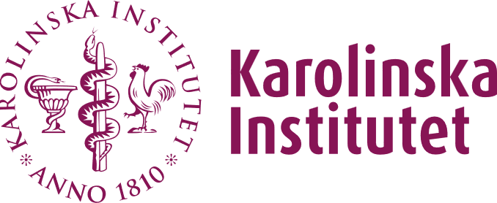
Strategic Research Program in Epidemiology and Biostatistics
SFOepi - Small grant application
SFOepi’s small grants funding mechanism is to support bottom-up initiatives in the field of Epidemiology or Biostatistics. Anyone employed at Karolinska Institutet (KI) or employed at Karolincka University Hospital (KS) with an affiliation to KI can apply for a small grants for workshops, events, courses, retreats, or other activities.
The conditions are that (1) the activity you plan must be open to and of interest to participants from all SFOepi departments at KI. (2) You must be clear in all your communication that this event is supported by SFOepi. (3) You will also need to send in a short report, shortly after your event, to SFOepi letting us know a little of how your event turned out and how you spent the money.
Please use this template for your application and answer the questions below.
The application Is limited to a maximum of 3 pages (including this text).

Main applicant
(Your name and KI-email)
Date of application
(Today’s date)
Date of event
(Start and end date)
Scientific aims
(Describe the scientific aim with the event you are planning and clearly state how it is connected to SFOepi)
Planned schedule
(Describe where and when are you planning to have your event and the set-up you will have)
Budget
(Describe what you will use the grant for in detail)
Target group for the activity
(Describe the target group for your event)

