Molecular Devices
ImageXpress HCS.ai
START-UP PROCEDURE
- Switch on the main power (1) (at the left side of the instrument)  - If the water objectives will be used, check the water level in the bottles with yellow lids (“Waste” and “Supply”).  - Press the button to load the samples (can also be done later)  OBS! Environmental controls (temperature, CO₂) can be started only from the software. | 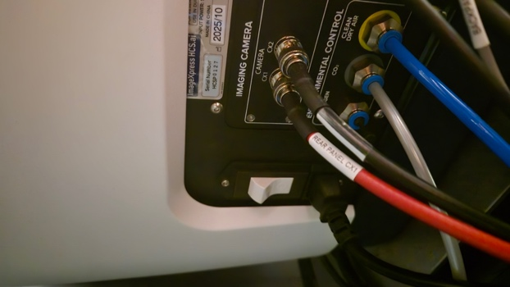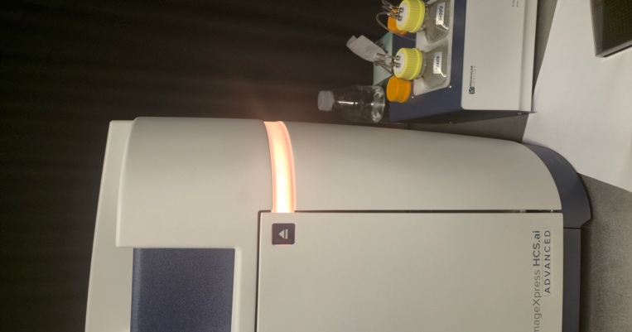
4) Switch on the software computer, and login with the Windows account BICuser (pw=BICuser).
7) Open the internet browser, login into iLab and go to the Kiosk. Start your session. Wait until the status will become .
8) First start the InCarta analysis software, and then MetaXpress Acquire.

OBJECTIVE |  | NA |  | WD | Immersion
4x |  | 0.2 |  | 20 mm | dry
10x |  | 0.45 |  | 4 mm | dry
20x Corr |  | 0.45 |  | 8.2-6.9mm | dry
20x W Corr |  | 0.95 |  | 0.99-0.9 mm | water
40x Corr |  | 0.8 |  | 3.6-2.8 mm | dry
40x W Corr |  | 1.15 |  | 0.61-0.59 mm | water
 |  |  |  |  | D=2000*NA/mag

Molecular Devices
ImageXpress HCS.ai
SHUT-DOWN PROCEDURE
Always shut down the instrument at the end of your session unless the next user is standing behind you.

1) Take away your samples.
2) Turn off incubation if that was used
2) Close the MetaXpress and InCarta software.
2) Finish your session in iLab Kiosk.
4) Sign out of BICuser account. Shut down Windows.
6) Turn off the power (1).
7) Check that the place is tidy and dispose any trash to the trash boxes situated at the entrance to the facility.

