EVIDENT
VS200 SLIDEVIEWER SILA
START-UP PROCEDURE
- Switch on the main power (1)  - Turn on the key on the C-FLEX light source  - Turn on the camera at the top of the instrument | 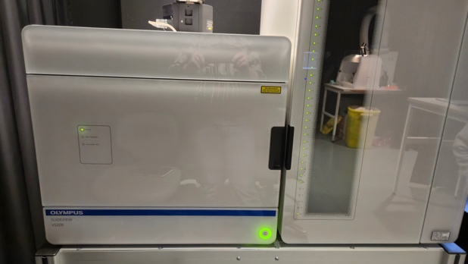  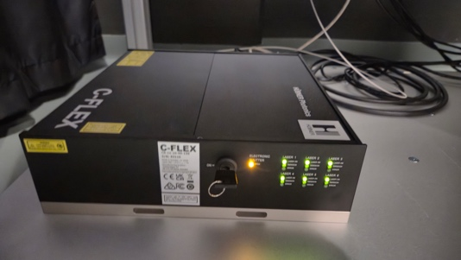  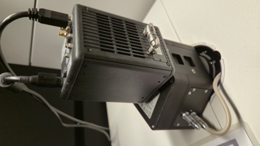
4) Switch on the software computer, and login with the Windows account BICuser (pw=BICuser).
5) Open the internet browser, login into iLab and go to the Kiosk. Start your session. Wait until the status will become .
6) Start the OLYMRUS VS200 Acquisition software.
7) To load the slides, click “Exchange trays” in the software. Open the door of the tower with the trays, take out the number of trays you need and put your slides in them. Insert the trays back to the instrument (light on the left side becomes green when properly inserted), close the door and press “Lock door” in the software.

OBJECTIVE |  | NA |  | WD | Immersion
2x |  | 0.06 |  | 5.8 mm | dry
4x |  | 0.16 |  | 13 mm | dry
10x |  | 0.4 |  | 3.1 mm | dry
20x |  | 0.8 |  | 0.6 mm | dry
40x |  | 0.95 |  | 0.18 mm | dry
40x OIL |  | 1.4 |  | 0.13 mm | Oil (autodispenser)
 |  |  |  |  | D=2000*NA/mag

EVIDENT
VS200 SLIDEVIEWER SILA
SHUT-DOWN PROCEDURE
Always shut down the instrument at the end of your session unless the next user is standing behind you.

1) Press “Exchange trays” and take away your slides from the holders, then put the empty holders back. Press “Lock door” to return to Home.
2) Close the MetaXpress software.
3) Finish your session in iLab Kiosk.
4) Sign out of BICuser account. Shut down Windows.
5) Turn off the camera (3); C-FLEX light source (2) and the power on the instrument (1)
6) Check that the place is tidy and dispose any trash to the trash boxes situated at the entrance to the facility.

