Zeiss Cell Observer START-UP PROCEDURE
1) Switch on the main switch (1)  2) If temperature would be used, turn on the incubator (2, below the table) and air blow (3). | 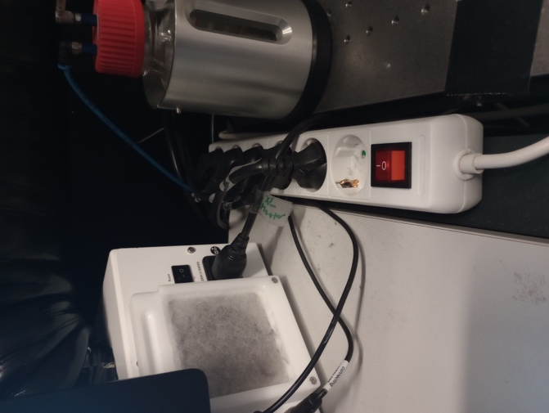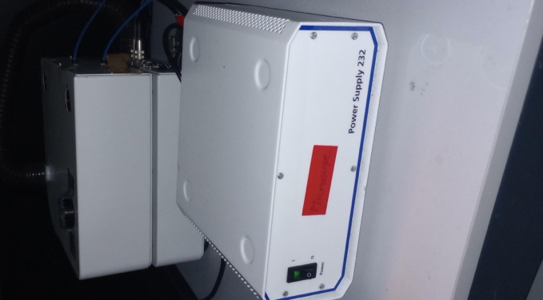
2) Check that the Power supply (4, below the table) and XY stage (5, on the right side of the microscope) are on. | 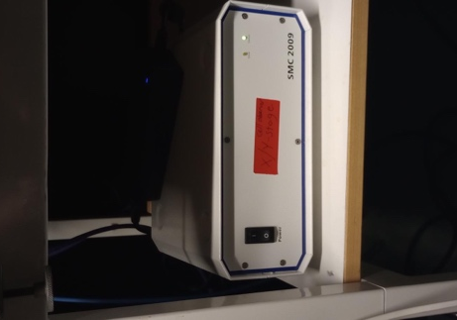
3) Turn on the microscope Power (6) | 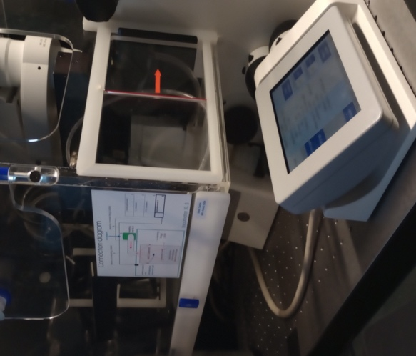
3) Switch on computer, and login with the Windows account BICuser (pw=BICuser).
4) Open the internet browser, login into iLab and go to the Kiosk. Start your session. Wait until the status will become . Note that late arrival (+30min) is automatically considered as NO SHOW in iLab, so a new session needs to be created.
5) Start the ZEN blue software . Log in into BICuser. Say yes to stage calibration if asked.
6) For the best imaging results, clean objectives you intend to use.

Zeiss Cell Observer SHUTDOWN PROCEDURE
Always shut down the instrument at the end of your session unless the next user is standing behind you.

1) Lower the stage.
2) Turn off incubator in the software or on the microscope pad. Turn off the incubator block (2) and the air blow unit (3).
OBS! Leave Power supply (4, below the table) and XY stage (5, on the right side of the microscope) ON.
3) Close the ZEN software and finish your session in iLab Kiosk .
4) Sign out of BICuser account. Shut down Windows.
5) Switch off the Microscope (6), then the Main switch (1).
6) Close the climate chamber to protect microscope from the dust.
7) Put on the dust protective cover.
8) Dispose of used lens paper and other items in the yellow boxes situated at the entrance to the facility.

