Olympus IX73 START-UP PROCEDURE
1) On the right side, turn on Olympus light power supply (1) and control box (2). Check that the Tango stage controller is on. | 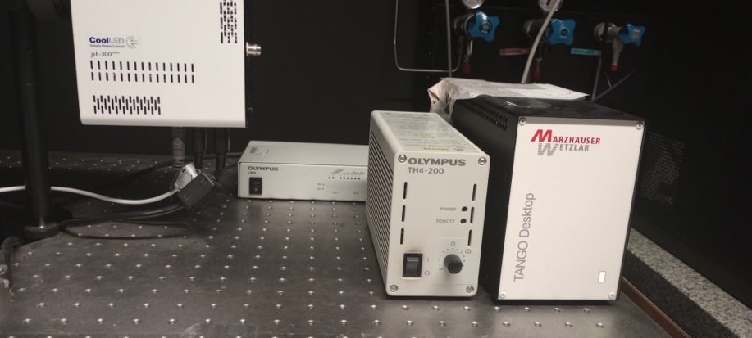
2) Switch on the software computer, and login with the Windows account BICuser (pw=BICuser).
3) Open the internet browser, login into iLab and go to the Kiosk. Start your session. Wait until the status will become 
4) Start the cellSens Dimention software 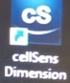
5) To view fluorescence, on the left side turn on the pE-300 LED unit (3) (ON appears at the left upper corner on the display). To view transmitted light, turn on the light source on the microscope stand (4). | 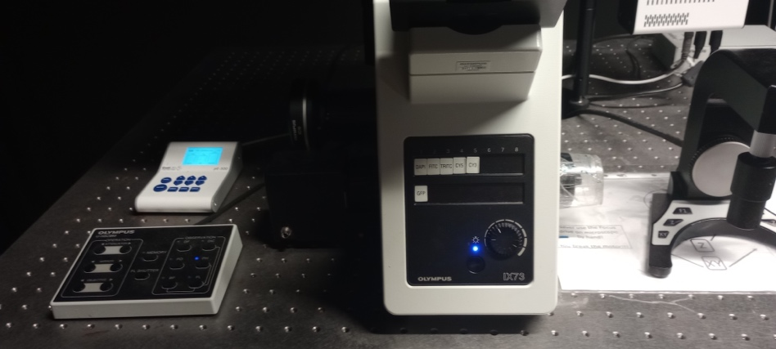
6) For the best imaging results, clean objectives you intend to use before imaging.

OBJECTIVE | NA | Manual magnif* | WD (mm) | Immersion
2x | 0.08 | 2X | 6.2 | dry
4x | 0.13 | 1.6X | 17 | dry
10x | 0.30 | 1.6X | 9.5 | dry
20x | 0.45 | 1X | 6.6-7.8 | dry
20x | 0.8 | 1X | 0.6 | dry
40x | 0.6 | 1X | 2.7-4.0 | dry
*Recommended.

Olympus IX73 SHUTDOWN PROCEDURE
Always shut down the instrument at the end of your session unless the next user is standing behind you.
1) Switch to 2x objective. Lower the stage.
2) Close the cellSens software and finish your session in iLab Kiosk .
3) Sign out of BICuser account. Shut down Windows.
5) Switch off the brightfield lamp (4) and pE-300 LED unit (3).
6) Switch off the Olympus control box (2) and light poser supply (1). OBS!!! Do not switch off the Tango stage controller.
7) Put on the dust protective cover.
8) Dispose of used lens paper and other items in the trash boxes situated at the entrance to the facility.

