NIKON CrEST SDM START-UP PROCEDURE
1) Optional for temperature + CO2 control, switch on the OKO lab temp control unit. It will take approx. 30min to warm up. | 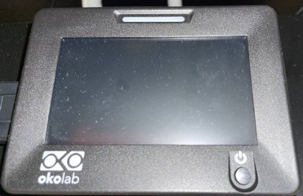
2) Switch on the Kinetix camera, button (1) on left. Wait for the camera initialization to be finished when the LED (arrow) on the camera is switched off. | 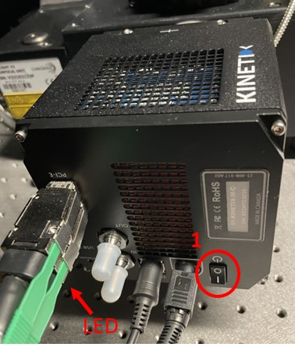
3) Turn on the CrEST Spinning Disk Unit (2) by pressing the POWER button. | 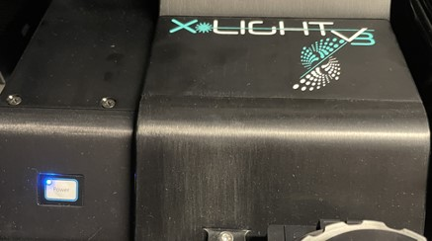  2
4) Switch on the Celesta laser unit (3) (on the rack on the right) and turn on the laser key (4). | 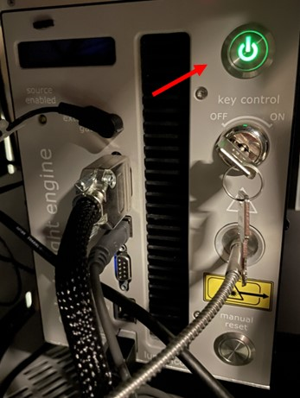  4  3
5) Switch on the Nikon control unit (5) and the fluorescence P800 LED unit (6). | 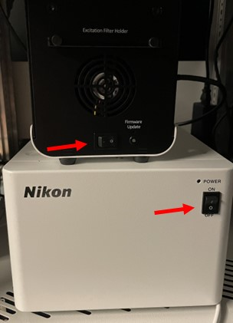  5  6
6) Switch computer, and login with the Windows account BICuser (pw=BICuser).
7) Open the internet browser, login into iLab and go to the Kiosk. Start your session. Wait until the status will become 
8) Start the NIS-elements software , login with your KI ID name (choose from drop-down menu) and password (same as username)
9) For the best imaging results, clean objectives you intend to use.

OBJECTIVE | NA | WD (mm) | Emm. Iris D (%)
4x | 0.2 | 20 | 100
10x | 0.45 | 4 | 90
20x | 0.8 | 0.8 | 80
20x LWD | 0.7 | 2.3 | 70
25x Sil | 1.05 | 0.55 | 84
60x Oil | 1.4 | 0.13 | 47
 |  |  | D=2000*NA/mag

Nikon CrEST SDM SHUTDOWN PROCEDURE
Always shut down the instrument at the end of your session unless the next user is standing behind you.

- If oil or silicon objective was used, clean the objective with lens paper!! Also clean the slide holder on the stage if this has been used.
- Take away the used stage insert and place them inside the incubator to the right side.
- Lower stage all the way down.
- Switch to 4x objective.
- Close the NIS-elements software and finish your session in iLab Kiosk.
- Sign out of BICuser account and shut down Windows / Computer.
- Switch off the Nikon control unit and the P800 LED unit.
- Turn the laser key to off, followed by switching of the Celesta laser unit
- Press the power button on the CrEST unit.
- Switch off the Kinetix camera
- Dispose of used lens paper and other items in the trash boxes situated in the wet lab at the entrance to the facility.

