Zeiss LSM800 CLSM START-UP PROCEDURE
- Switch on the System switch (1), followed by the Components switch (2). The laser key is ALWAYS on.  - Turn on CoolLED unit (3). | 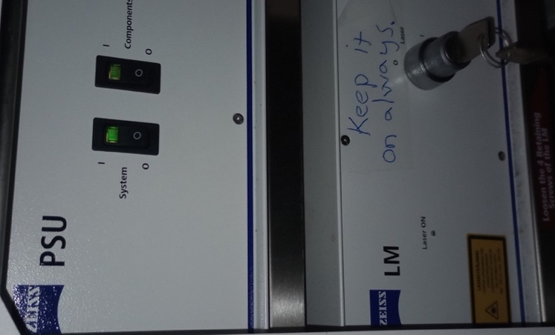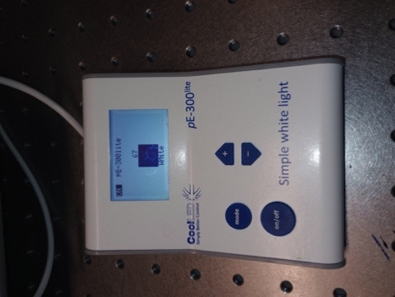
DO NOT TOUCH the other switches, they should be on all the time.  OBS! It is normal that Definite focus controller fc12 shows OFF on the display. | 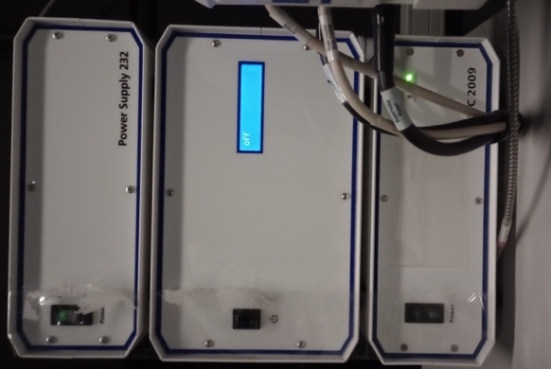
3) Switch on computer, and login with the Windows account BICuser (pw=BICuser).
4) Open the internet browser, login into iLab and go to the Kiosk. Start your session. Wait until the status will become . Note that late arrival (+30min) is automatically considered as NO SHOW in iLab, so a new session needs to be created.
5) Start the ZEN blue software . Say yes to stage calibration if asked.
6) For the best imaging results, clean objectives you intend to use.

OBJECTIVE | NA | WD | Immersion | Coverglass thickness
5x | 0.25 | 12.5mm | dry | 0.17mm
10x | 0.45 | 2.0mm | dry | 0.17mm
20x | 0.8 | 0.55 mm | dry | 0.17mm
40x W | 1.2 | 0.28mm | water | 0.14-0.19mm
40x Oil | 1.2 | 0.21mm | oil | 0.17mm
63x Oil | 1.4 | 0.19mm | oil | 0.17mm

Zeiss LSM800 CLSM SHUTDOWN PROCEDURE
Always shut down the instrument at the end of your session unless the next user is standing behind you.

1) If an oil or water objective is used, clean the objective with lens paper. Also clean the slide holder on the stage if this has been used.
2) Switch to 5x objective. Lower the stage until the lower Z-limit reached.
3) Close the ZEN software and finish your session in iLab Kiosk .
4) Sign out of BICuser account. Shut down Windows.
5) Switch off the CoolLED lamp unit.
6) Switch off the Components, followed by the System switch. The laser key remains on!
7) Put on the dust protective cover.
8) Dispose of used lens paper and other items in the trash boxes situated at the entrance to the facility.

