LEICA STELLARIS 5 LIA
START-UP PROCEDURE
- Switch on the main power (1)  - Switch on the laser power (2)  - Turn the laser key (3) | 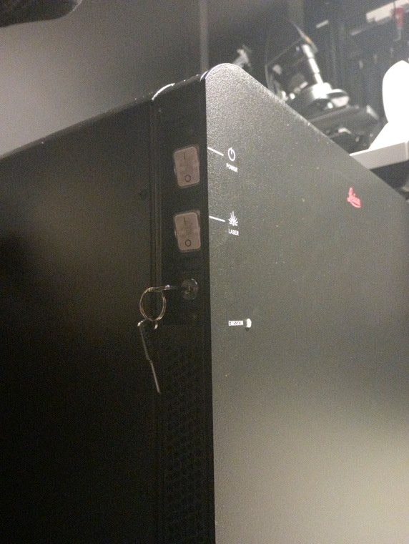
4) Check that the LED unit is on | 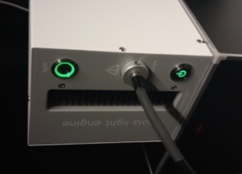
5) Switch on the software computer, and login with the Windows account BICuser (pw=BICuser).
7) Open the internet browser, login into iLab and go to the Kiosk. Start your session. Wait until the status will become .
8) Start the Leica X software | 
9) For the best imaging results, clean objectives you intend to use before imaging.

OBJECTIVE |  | NA |  | WD |  | Immersion
5x |  | 0.15 |  | 13.7mm |  | dry
10x |  | 0.40 |  | 2.56mm |  | dry
20x |  | 0.75 |  | 0.62 mm |  | dry
20x Gly |  | 0.75 |  | 0.66 mm |  | Gly
40x Gly Corr |  | 1.25 |  | 0.35 mm |  | Gly
60x Oil |  | 1.4 |  | 0.140 mm |  | Oil
 |  |  |  |  | D=2000*NA/mag

LEICA STELLARIS 5 LIA
SHUTDOWN PROCEDURE
Always shut down the instrument at the end of your session unless the next user is standing behind you.

1) If an oil or glycerol objective was used, clean the objective with lens paper. Also clean the slide holder on the stage if this has been used.
2) Switch to 5x objective. Lower the stage all the way down until the lower Z-limit reached.
3) Close the LASX software and finish your session in iLab Kiosk .
4) Sign out of BICuser account. Shut down Windows.
5) Turn the laser key (3) to off position, followed by switching of the laser unit (2).
6) Turn off the main power (1).
7) Put on the protective cover to keep the dust away.
8) Dispose of used lens paper and other items in the trash boxes situated at the entrance to the facility.

