Evident FV40000 CLSM START-UP PROCEDURE
1) Start by switching on computer – it has to be on before the system starts. Login with the Windows account BICuser (pw=BICuser).
2)If will be used, turn on climate control:  CO2/O2 at the bottom, Temperature in the middle and Ventilator on the top. The switches are at the back. To start the heating and CO2, use arrows (the indicator should show ON). | 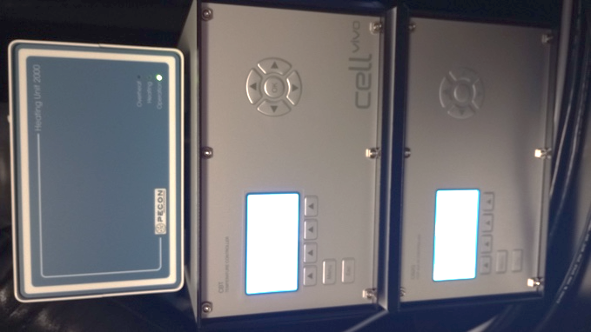
3) Turn on the green master switch on the top (3). Turn on the key to a ON position and pirullinos for the lasers that would be used (i.e. 405;488; 561;640 – all have separate controls) (4). | 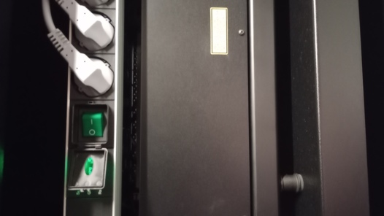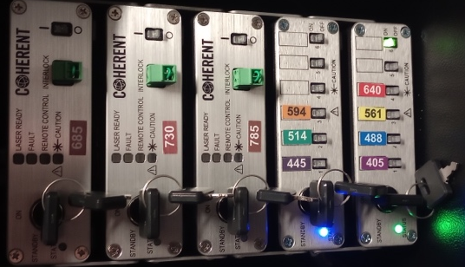
5) Turn on the Evident pad (switch at the back) | 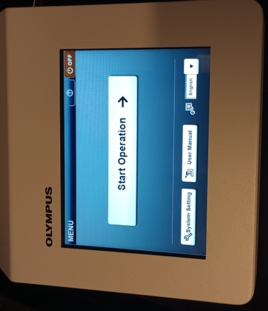
4) Open the internet browser, login into iLab and go to the Kiosk. Start your session. Wait until the status will become . Note that late arrival (+30min) is automatically considered as NO SHOW in iLab, so a new session needs to be created.
5) Start the CellSense software.
6) For the best imaging results, clean objectives you intend to use.

Evident FV40000 CLSM SHUTDOWN PROCEDURE
Always shut down the instrument at the end of your session unless the next user is standing behind you.

1) If an oil or water objective is used, clean the objective with lens paper. Also clean the slide holder on the stage if this has been used.
2) Switch to 2x objective. Lower the stage until the lower Z-limit reached.
3) Close the CellSense software and finish your session in iLab Kiosk.
4) Sign out of BICuser account. Shut down Windows (optional).
5) Switch off the Evident pad (5) unit.
6) Switch off the pirullinos for lasers followed by the Key on Stand ON position (4). Turn off the green master switch (3).
7) If the climate control was used, turn all units off.
8) Dispose of used lens paper and other items in the trash boxes situated at the entrance to the facility.

