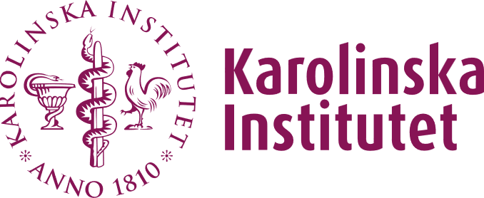

Certificate for making research infrastructure at KI accessible to external users

Name of core facility:
___________________________________

The following services and/or goods are made available at the core facility :
1.
2.
3.

It is hereby certified
- that the core facility is made accessible within the framework of the university's assignments
- that procedures are in place to ensure that external users hold the necessary permits and that use is otherwise conducted in accordance with applicable regulations
- that any safety risks associated with making the facility available have been considered
- that procedures exist to ensure that users have relevant training or that staff provide assistance
- that any training requirements are clearly stated on the core facility's website
- that for every order from an external party, an agreement is entered into
- that a process for calculating the fee to ensure full cost recovery has been established
- that a market survey has been conducted in accordance with the guidance (Chair’s decision in the Infrastructure Committee, ref. 1–793/2024) to ensure that the fee does not distort competition
- that a decision regarding the fee has been made
- that the prioritisation of external use is carried out in accordance with the Vice-Chancellor’s decision ref. 1–431/2024 when access is limited and is clearly stated on the core facility’s website, and
- that contact information is available on the core facility’s website.

Head of department

--------------------------------------------------------

Department

--------------------------------------------------------

The certificate is to be sent to lena.lewin@ki.se .

