Important equations for light microscopy

Background knowledge

Definition of resolution
The resolution is a distance. Its unit in light microscopy is usually in nm. The resolution of an objective is the smallest distance between 2 points in the sample that the objective can resolve (i.e. we can tell with certainty that there are 2 dots. They do not fuse into 1 dot). When the resolution value decreases, the resolution improves.
There are 2 types of resolution to consider: the xy and z resolutions delivered by the objective (optical resolution) and the xy and z resolutions at which we record the images (digital resolution).

Choice of equations
If you search online how to calculate the xy resolution and the z resolution for microscopy, you will find several equations for the optical resolution, and they will give slightly different results. Each of these equations is only valid:
- in a specific context (for example, a very closed confocal pinhole),
- if the method to record the image fulfils the Nyquist sampling theorem,
- last but not least, if the sample is perfect. In biology, sample imperfection often limits the resolution in images.
Unfortunately, it is common for websites to mention one equation without specifying any of these 3 points. This leads to a lot of confusion.
In this course, for the sake of simplicity, we will use the same xy and z equations for the optical resolutions, regardless of the imaging modality and context. We also put a lot of emphasis how to prepare high quality samples.
For the same reason, we will also use a factor of 2 for Nyquist sampling, although anything from 2.3, 3 or more can be found in the literature, again depending on the context.

In the equations below:
- n is the refractive index of the objective immersion medium
- λem is the wavelength of the emitted light
- NA is the numerical aperture of the objective
- Mag is the total magnification (magnification of the objective * extra magnification)

Refractive indices (n)
Refractive index (n) | 1 | 1.33 | 1.47 | 1.52
Medium | Air | Water | Glycerol/silicon oil | Oil
Sample type | N/A | Cell culture | Most uncleared tissues | Cleared tissues

Brightness of the objective
NA⁴/Mag²

Optical resolution (resolution of the objective)
The optical resolution is the resolution delivered by the objective at a given wavelength and is limited by diffraction if the sample is perfect.

xy optical resolution (= xy radius of the PSF main lobe = Rayleigh equation)
0.61*λem/NA

z optical resolution (= z radius of the PSF main lobe = objective depth of field). More details here.
2n*λem/NA²

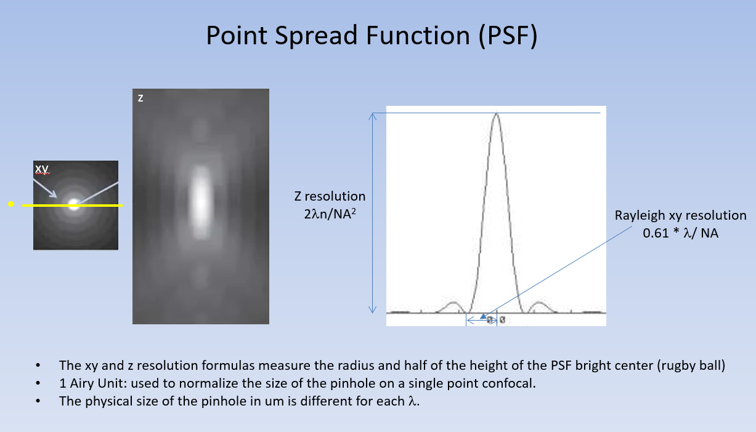

Nyquist sampling theorem (digital resolution = the way we record images)
Let’s imagine that we want to watch a high-resolution movie at home. The resolution of the TV used to play the movie must match or exceed the resolution of the movie, if we want the movie to be displayed at its best quality. If the TV is not good enough, its resolution will limit the quality of the movie.
The same is true in microscopy. At a certain wavelength, the objective resolution (optical resolution) is limited by diffraction and by the quality of the sample. If we record the image produced by the objective at a too low digital resolution (with large pixels), the final image will not display the fine details resolved by the objective.
The Nyquist theorem adapted for microscopy tells us that to be reliably recorded, each detail resolved by the objective must be measured (=sampled) by 2 pixels or more.

Required xy image pixel size (in nm) to reliably record all details resolved by the objective:
(0.61*λem/NA)/2 or smaller
The pixels in each image should be equal or smaller than the number given by this equation. You can usually see the size of the pixels in the microscope software, if the microscope is calibrated AND if you save the image in the original format recommended by the manufacturer to preserve the metadata.
Imaging with pixels that are larger than the number given by this equation is called undersampling in xy.
On single-point confocals, one can freely choose the xy pixel size by:
- choosing more or less pixels in a given scan area, or
- zooming more or less, for a given number of pixels.
A convenient button (usually called Nyquist or Optimal) is found in the software of single-point confocals to adjust the xy pixel size to the Nyquist theorem.
On camera-based systems. Cameras have recording devices that are confusingly called camera pixels. Their size is in um. Because cameras record not only the intensity but also the xy information in the image, the xy pixel size is fixed for a given magnification. This is why on some microscopes, it is possible to increase the magnification by adding a lens, without changing the objective.
Image pixel size = Camera pixel size/(obj mag * lens mag)

Required z voxel (=3D pixel) size (in nm) to reliably record all details resolved by the objective (only for z stacks):
(2n*λ/NA² )/2 or smaller
The z step used to record a z stack should be equal or smaller than the number given by this equation. On all microscopes, one can freely choose the size of the z step to acquire a z stack. A convenient button (usually called Nyquist or Optimal) is found in the software of all microscopes to adjust the z step to the Nyquist theorem.
Acquiring a z stack with a z step larger than the number given by this equation is called undersampling in z.

What happens when we undersample?
We can estimate the smallest distance (in xy and in z) that we need to resolve in the images to answer our scientific question. We then need to ensure the following:
- The sample quality must be good.
- The objective must be able to resolve this distance.
- The way we record the image must produce pixels that are half of the distance to be resolved, or smaller.
When we undersample, the resolution in the image (or the z stack) is limited by the recording/sampling instead of by the objective. According to the Nyquist theorem, we can only reliably record details that have been sampled twice or more. Therefore, when we undersample, the resolution becomes 2x the pixel size (or the z step) instead of being what the objective delivers.

Actual xy resolution in an undersampled image:
Image pixel size *2

Actual z resolution in an undersampled image:
Z step *2
Additionally, we create aliasing artifacts that not distinguishable from the real sample.

What is the best resolution that a camera can deliver?

Best xy resolution that a camera can resolve:
2* image pixels

Sampling in time
The Nyquist theorem is conveniently applicable to measuring intensity variations over time. One needs to consider the sample and scientific question to determine the time necessary for a significant change to occur in the phenomenon one wants to record. The time interval that fulfils the Nyquist sampling theorem is equal to half that time or smaller.

References:
Leica website about resolution

