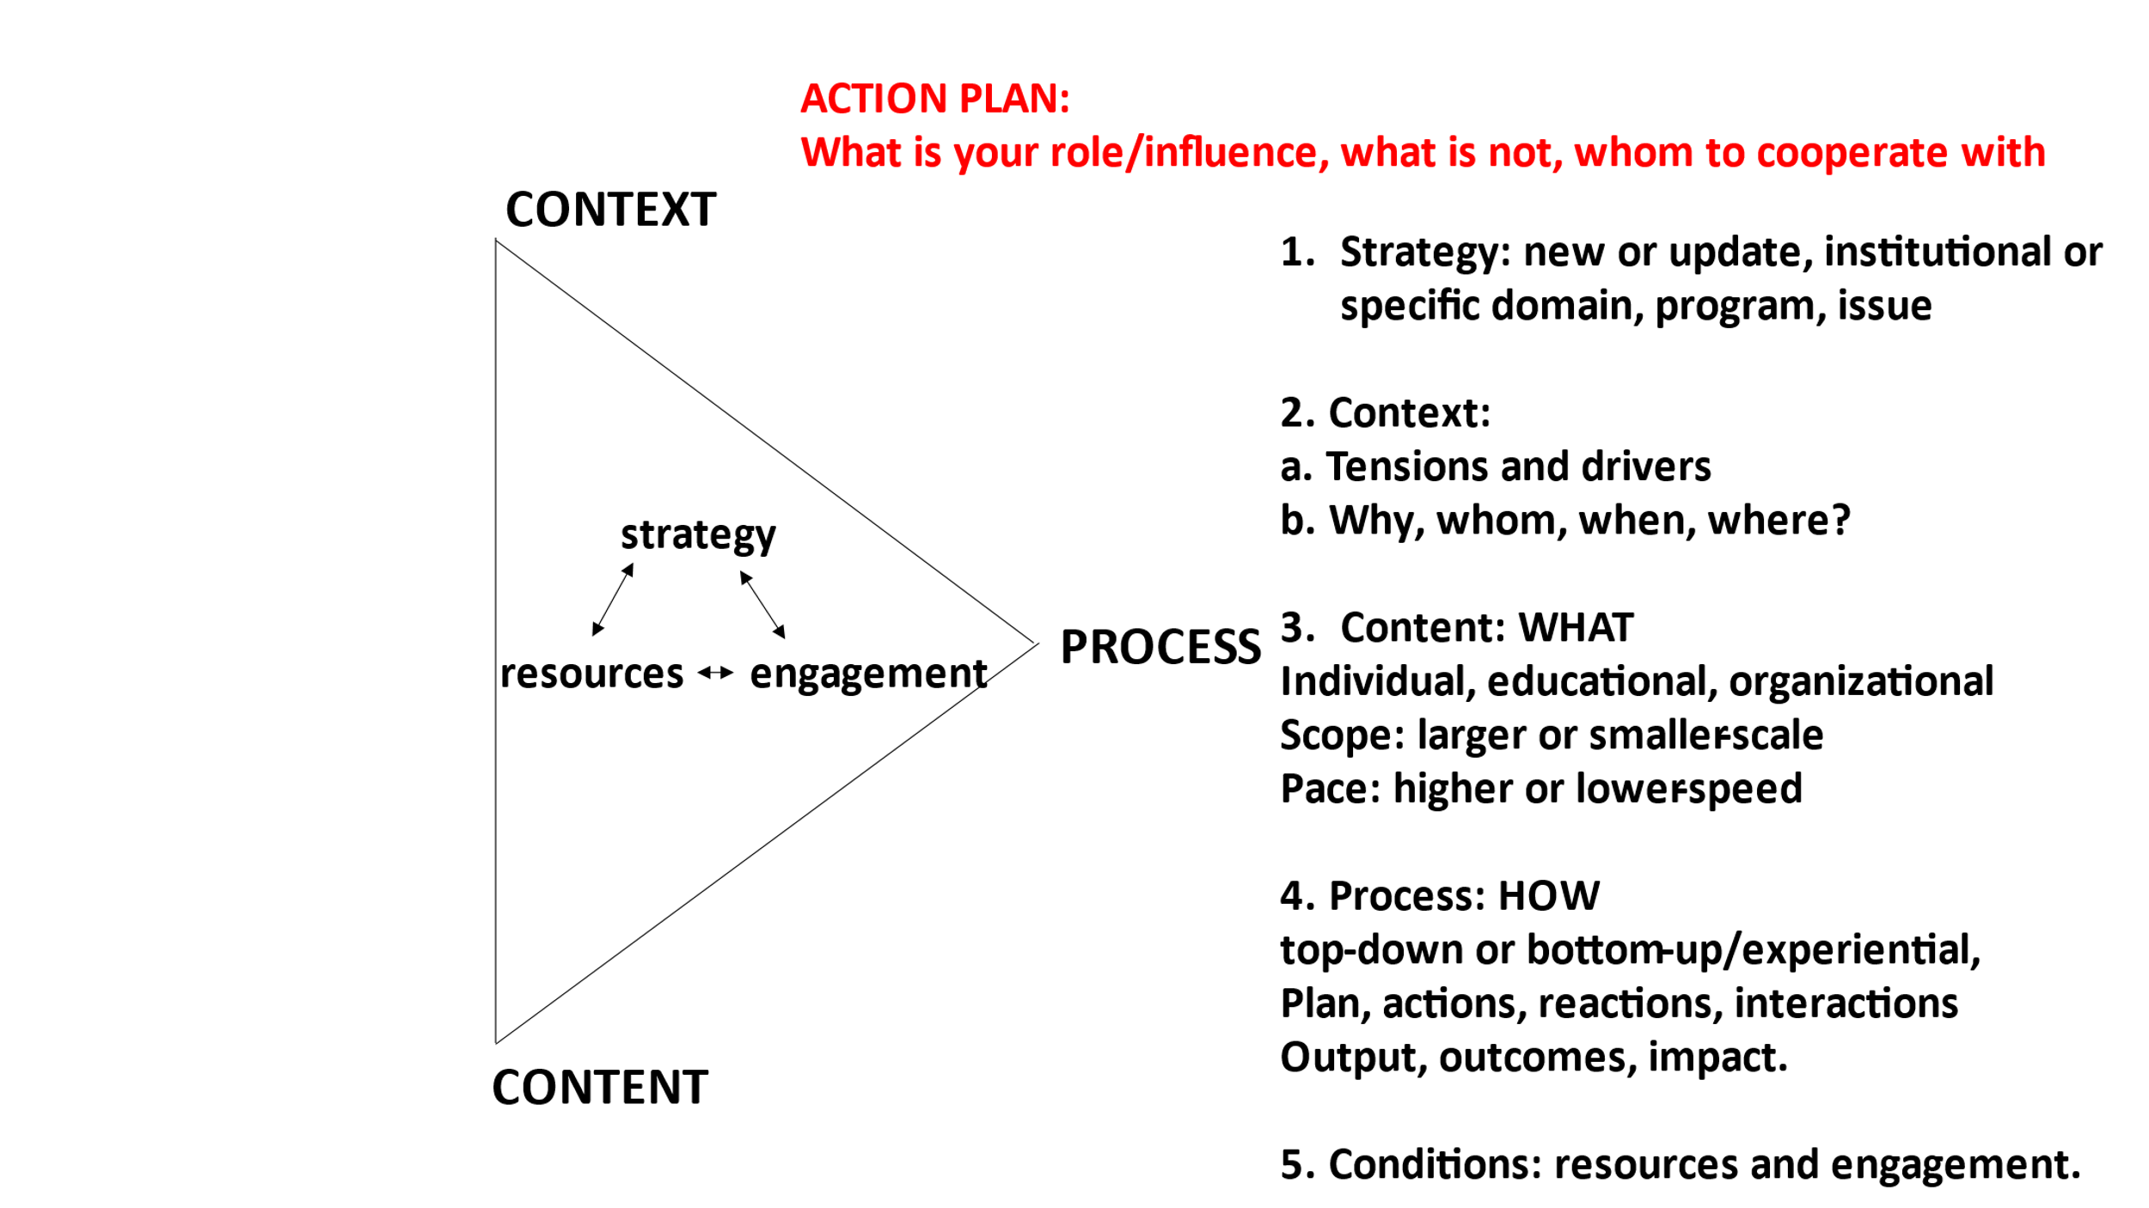

Please note that the steps are interrelated but can be followed differently depending on your context and needs.

| **STEPS** | **GUIDELINES** |
| --- | --- |
| 1. Diagnosis of **contex**t (why, with whom, when, where) | * Can you identify **blockers/tensions, drivers,** and **achievements**? * **Why** is this language strategy/policy important? What are the primary (shared) needs, problems, and goals? * For **whom** is this important? Identify your key stakeholders (internal and external). Are there stars/role models/ambassadors? * **When** is the best time to do this?   For example, a new strategic plan period, accreditations, experienced problems, European programs/guidelines, new leadership, new legislation, etcetera.   * **Where** to start?   At what level, in which domain, department, or study program? |
| 1. Developing a **strategy/policy** for language development, monitoring, and evaluation. | 1. **Adequate:** as needed and feasible  * Will it be a new strategy/policy or an update? * Will it concern the whole institution or a specific part? * Will you address language awareness, multilingualism, and parallel language use? * Can you align with a strategic plan, role models, good practices, accreditations, or other drivers/relevant developments in your context?  1. **Explicit:**  * Make the meaning and implications of language clear for the particular context(s) and stakeholders.  1. **Integrative:**  * develop a shared vision and goals based on values and principles, including adequate communication structures and plans. |
| 1. **What** can be changed (**content**) | * Depending the specific context,   what changes seem most urgent or feasible?   * Together with your key stakeholders, decide the **scope** (smaller or bigger changes) and **pace** (higher or lower speed) of change. * What kind of changes does it concern? For example, * individual: awareness, competencies, language use; * changes in study programs, study associations, welcoming, introductions/onboarding,   selection/recruitment;   * changes in governance boards. |
| 1. **How** to do this (**process**) | * Depending the context and the content, what process approach seems most appropriate? * Generally, you need a **top-down strategic** approach, with larger-scale changes urgently needed and sufficient support in a cooperative environment with mostly one-way communication. * Generally, you need a **bottom-up, experiential** approach with smaller-scale changes and diverse perspectives that require more two-way communication. * Generally, the context requires **balancing** the two approaches adequately. * Operationalize your (shared) goals in **output, outcomes, and impact**. * Output: realized numbers, products, and services, and the quality perception. * Outcomes: the cumulative result of actions and activities. * Impact: the influences/consequences of multiple actions/activities. * Operationalize **plans, actions, activities, and space for reactions and interactions.** * Develop **indicators** for monitoring your process, preferably quantitative and qualitative. |
| 1. What do you need (particularly) in terms of **financial and human resources**? | * Think of budget, time, support from leadership, expertise, language awareness/mindset, networks/platforms. * What resources are **available**? * What **other resources** do you need? |
| 1. How to **engage** the key stakeholders? | * Who are the main stakeholders to engage? (internal and external) * Whom to start with? * What do your stakeholders bring?   Think of expertise, competencies, mindset, leadership, particular drivers.   * What do your stakeholders need?   For example, to develop specific language competencies, or opportunities to discuss language issues. |