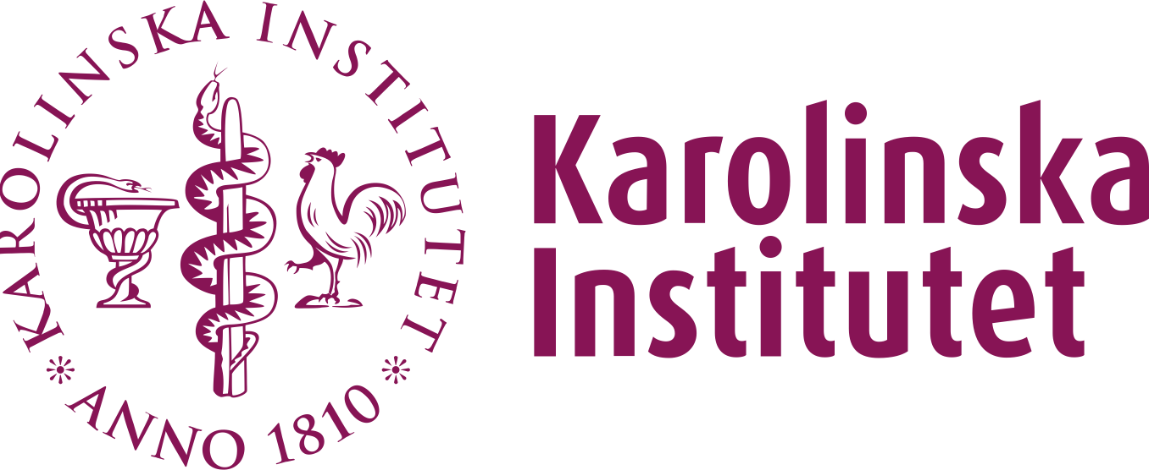
Strategic Research Program in Epidemiology and Biostatistics
SFOepi - Small grant application
SFOepi has a small grants funding mechanism to support bottom-up initiatives in the field of Epidemiology or Biostatistics. Anyone employed at KI can apply for small grants of up to 100 000 SEK any time of the year for workshops, events, courses, retreats, or other activities.
The conditions are that (1) the activity you plan must be open and of interest to participants from all SFOepi departments (MEB, KEP, IMM, GPH and ARC/NVS). Interaction with other SFOs and disciplines at KI are encouraged. (2) You must be clear in all your communication that this event is supported by SFOepi. (3) You will also need to send in a short report, shortly after your event, to SFOepi letting us know a little of how your event turned out and how you spent the money.
Main applicant
Your name and KI-email
Date of application
Today’s date
Date of event
Start and end date
Scientific aims
Describe the scientific aim with the event you are planning and clearly state how it is connected to SFOepi.
Planned schedule
Describe where and when are you planning to have your event and the set-up you will have.
Budget
Describe what you will use the grant for in detail. We may support one lunch or coffee break daily.
Target group for the activity
Describe the target group for your event.

