INFORMATION ABOUT THE PROJECT "PREVENTION OF BLOOD CLOTS IN THE LEG"
- Background and purpose
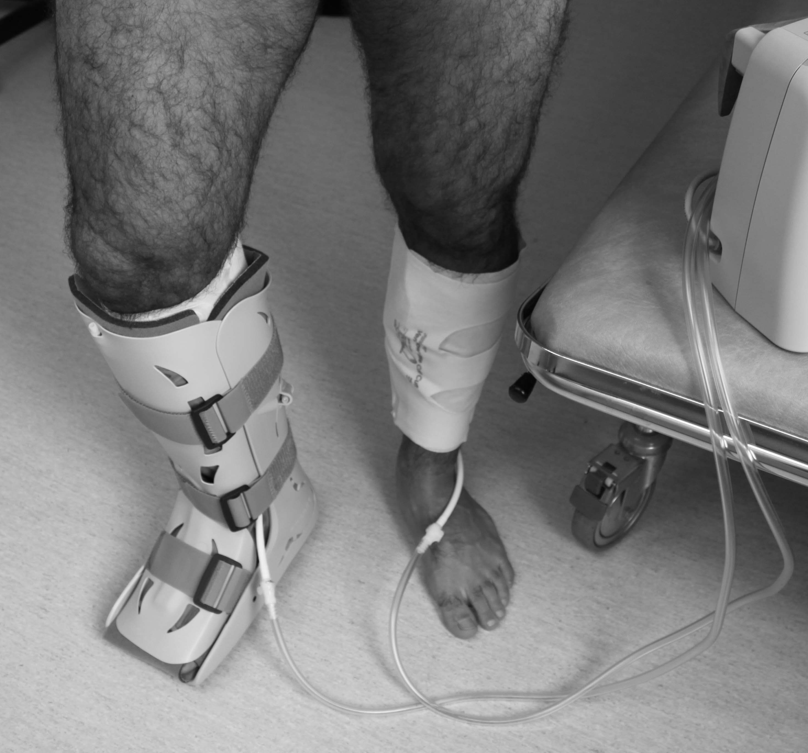
The purpose of this project is to improve treatment for those who have suffered from an injury and is immobilized (eg plaster or plastic orthosis). After an injury or as newly operated, you may become less mobile than normal. We know that immobilization has some negative consequences for the body, e.g. it may lead to an increased risk of blood clots. One form of treatment to counteract the negative effects of immobilization that also could improve recovery is treatment with intermittent pneumatic compression (IPC), which increases blood flow. The treatment with the IPC means that a cuff is applied around the calf and with regular cycles it is filled with air to give an external pressure (Figure 1). In this way, the flow of blood from the foot to the heart increases, the swelling of the leg decreases, and the risk of blood clots is decreased.
The purpose of the project is to analyze whether addition of IPC can reduce the risk of blood clots and increase the healing in the injured leg. This method is already used in many hospitals, both in Sweden and other countries. To analyze whether treatment with IPC reduces the risk of blood clots, ultrasound examinations of the legs
will take place after approximately 6-8 weeks.
Figur 1. Exempel på plaststövel med IPC behandling på bägge benen.

- How will the study be performed?
The study investigates the incidence of blood clots during immobilization in patients with an Achilles tendon rupture or an ankle fracture. You that participate in the study will be randomized between two treatment options. You will either receive treatment according to the current routine with plaster cast/orthosis or with the addition of IPC. If you are randomized to the second treatment option, you will in addition to orthosis also receive IPC during the time when the lower leg is immobilized (Figure 1). Those who are randomized to IPC should use it as much as possible, but at least 10 hours per day. The IPC can also be used at night when sleeping. You can turn off the IPC during activity. If you have been randomized to the IPC, you will have to register how many hours per day the pump has been used. In connection with a return visit after approximatly 6-8 weeks, your injured leg will be examined with ultrasound to determine if a blood clot has formed. At 6 and 12 months you will answer surveys regarding your current health status.
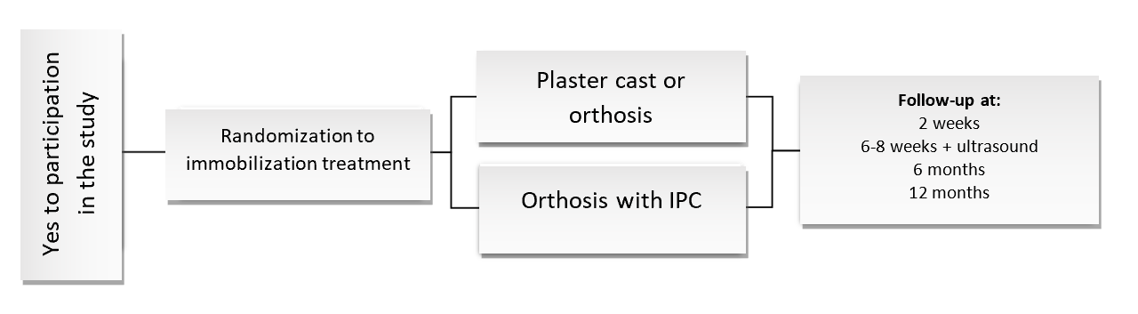

- What are the risks?
We assess that you will not be exposed to any additional risks, other than the normal risks associated with lower leg immobilization, by participation in the study. In previous studies, treatment with IPC has been shown to have positive effects on healing and recovery after injury. There is no research that suggest that treatment with IPC would increase the risk for poor healing compared to current treatment today.

- Are there any benefits?
If you participate in the study, you will be followed up with extra investigations which means that any possible complications can be detected and treated at an early stage. In other conditions, compression treatment has been shown to protect against blood clots.

- Management of data and confidentiality
Contact information will be collected and saved. The results of the tests will be saved in computerized form after being coded for each patient. The results of this study will be compiled and published in a medical journal, which will be kept confidential without the participants names being revealed under any circumstances. Only the person analyzing the results can identify the individual participants. Collected data is stored by law for 10 years. The code key is stored locked and there is full privacy protection for all registered information. No unauthorized person will be able to access your data. The person responsible for personal data is Karolinska University Hospital and the “Data Protection Agent” can be contacted as follows: “Dataskyddsombudet”, Karolinska University Hospital, 171 76 Solna, tel: +46 8-517 700 00 (exchange). The project is approved by the regional ethics review board in Stockholm.

- How do I get information about the study results?
You can easily see the results through the page http://www.ki.se/mmk/stop-leg-clots when the study is completed (about 2021).

- Insurance, compensation
You are covered by the patient injury insurance. No compensation is paid to participants in the study.

- Voluntary participation
Participation is completely voluntary. You may cancel your participation in the study at any time, without any justification and without affecting your continued care.

- Responsible
“Forskningshuvudman”: Karolinska University Hospital, Stockholm County Council

If you have any questions, please contact:
LOCAL CONTACT PERSONS

Project leader: Primary Investigator:
Simon Svedman, doctor, PhD student Paul Ackermann, Associate Professor, specialist in orthopedics
Orthopedic department Orthopedic department
Karolinska University Hospital Solna Karolinska University Hospital Solna
171 76 Stockholm, +46 765930550 171 76 Stockholm, Tel: +46 8-517 70 000

