Ultrasound protocol - STOP Leg Clots
Ultrasound, leg
Ultrasound - device
Use a machine equipped with linear probes with frequencies between 4 and 6 MHz. For larger patients, a curved 4 MHz probe may be used. Color flow Doppler can be replaced by Power Doppler if needed (more sensitive to lower flow but not sensitive to flow velocity or direction).
Preparation of the patient
The patient's lower body should be undressed.
To assess the venous system, one should have a certain filling of the veins. This is conveniently accomplished by examining the patient in a sitting or semi-standing position on a tilting board with at least a 45 degree slope. When examining the lower leg you can have the patient sitting with the lower leg hanging over the edge of the gurney and the foot in the knee of the examiner.
Measuring principles
Registration of deep veins in cross-section with 2D-view and simultaneous compression of the blood vessel against a solid background. Doppler flows are also recorded after intermittent distal compression to determine venous filling or reflux. The calf is compressed while the flow is recorded in the examined vessel segment with color and/or pulsed doppler.
Principle of quantification
The presence of thrombosis can be detected in several ways:
Thrombosis visible in 2D-view – this assumes altered echogenicity in thrombosis formation. A thrombosis gradually becomes more echogenic, but at a very early stage, the thrombosis has low echogenicity and very similar to that of blood. An old thrombosis can also be difficult to distinguish from surrounding connective tissue due to shrinkage of the affected vessel.
The top of the thrombosis – figure

Non-compressible vein - normally it is possible to compress the vein completely and if this fails it indicates that the vein is filled by (possibly a low echogenic) thrombosis (however, the vein may be difficult to compress for other reasons).
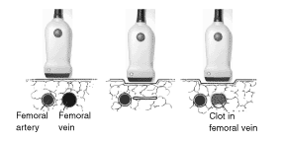

Duplicated v poplitea with both branches filled by thrombosis (cross-sectional image) - Figure
Dilated vein - a vein affected by thrombosis dilates, probably not only because of hemodynamic reasons but also with an active myogenic mechanism. A side difference between e.g. the width of the femoral vein may therefore speak for thrombosis, but the variation in vessel diameter is large.
Deep lower leg veins lack flow and are dilated (longitudinal section). Arterial flow is seen between the veins. Figure

Lack of color flow - normally it is easy to provoke flow that fills deep veins, and if this fails, especially if the flow is fragmented, it speaks for thrombosis. Note that this finding is difficult to evaluate.
Border flow - variant of the previous point - a fresh thrombosis is often not wall-solid, but fills central parts of the lumen, while flow tends to follow the vessel wall. This is often visible as a cross-section and this finding is much more specific than “lack of color flow”.
Collateral flow - deep vein thrombosis obstructs the flow there, increasing the need for collateral vein flow. Sometimes small deep veins are seen with increased flow at distal compression, often increased flow is seen in superficial veins and sometimes there is a doubling of deep veins where a channel takes over the flow. Mechanisms for the development of collateral veins may be hemodynamic with increased distal pressure and greatly increased flow in small veins, possibly there are also biochemical/angiogenic mechanisms.
Validation
The examination is performed in the presence of two investigators, if needed and if an extra investigator is accessible. This will lead to an internal control at every examination.
Every positive examination should be saved digitally and sent to the responsible radiologist in the study.
Execution of the examination
The study includes the deep veins of the leg as well as the muscle veins. The veins of the legs have varying anatomy, but generally they run as follows:
Deep veins
- V femoralis communis, short segment extending from the ligamentum inguinalis to the branch to v femoralis superficialis and profunda
- V femoralis (superficialis), which runs deep on the medial side of the thigh and into the adductor canal towards the knee
- V femoralis profunda, deeper than femoralis (superficialis), also on the medial side of the thigh
- V poplitea, dorsally in the popliteal crease
- V tibialis posterior, dorsal of the lower leg, on the medial side
- V fibularis, dorsally in the lower leg, on the lateral side.

Muscle veins
- The term "muscle veins" is most commonly used for perforant vessels that represent a communication between the superficial and deep system and is best seen in the lower leg, in the gastrocnemius muscle.

Examine the deep veins. It is easy to "lose" the femoral vein as it deepens into the adductor canal. Use your free hand to push the thigh dorso-laterally so that the medial side of the thigh shows better. In doubt, use Doppler to identify vessels: the arteries have pulsating flow, the veins have non-pulsating flow (and in the opposite direction).
Unlike the superficial veins, and the femoral veins, the deep veins of the lower leg are doubled and, classically, they are shown in cross sections on each side of the corresponding artery. Keep in mind that both branches must be compressible and with flow, as thrombosis can occur in only one of the branches. In order to verify the blood flow in the veins, they must be compressed distally, not proximally, since the flaps does not allow the flow from the proximal direction.

Sample Pictures
V Femoralis without compression V Femoralis with compression
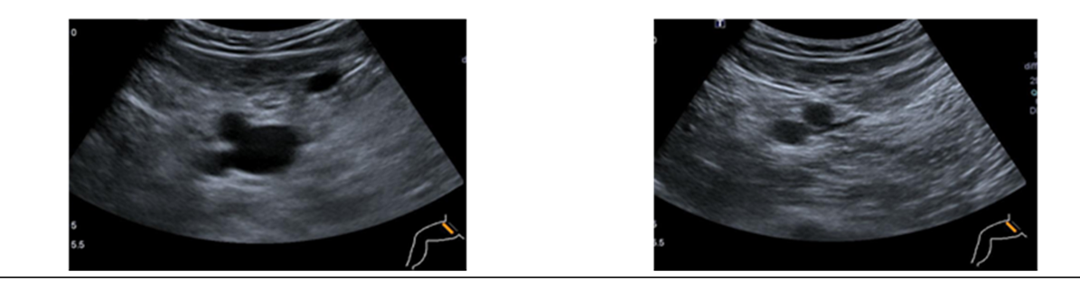

V Femoralis with transversal doppler V Femoralis with longitudinal doppler
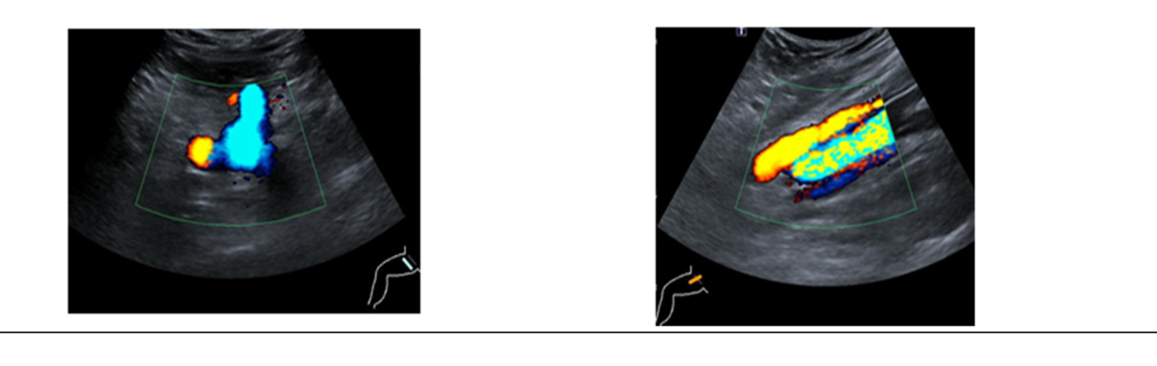
V poplitea without compression V poplitea with compression
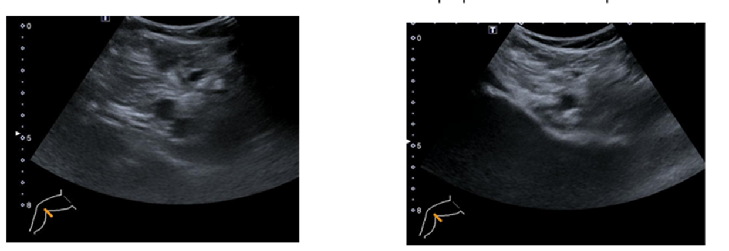
V poplitea with doppler
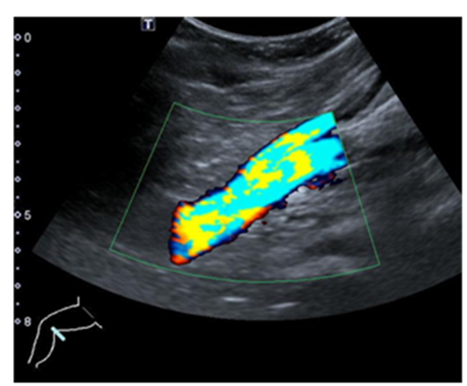

The deep veins of the lower leg
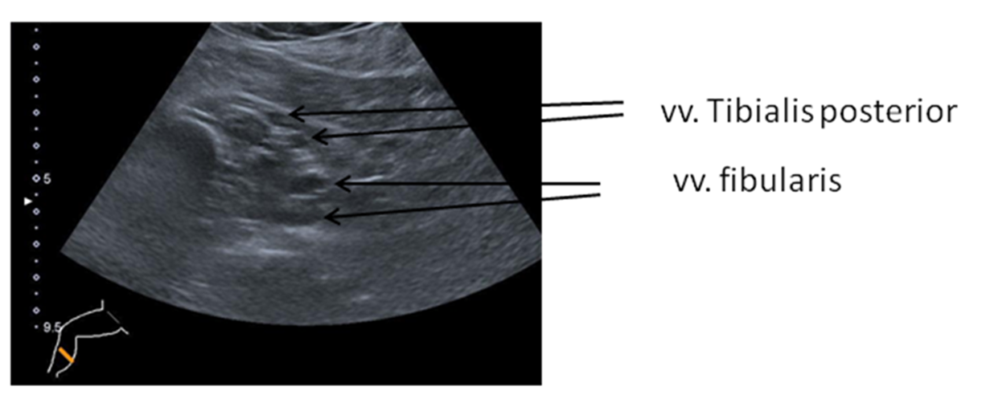

The deep veins of the lower leg with doppler
