Delegate administrative rights to a member of your group
- Open iLab OncPat Core facility page: https://karolinska.corefacilities.org/service_center/show_external/3714 and click on Manage Groups – My Group
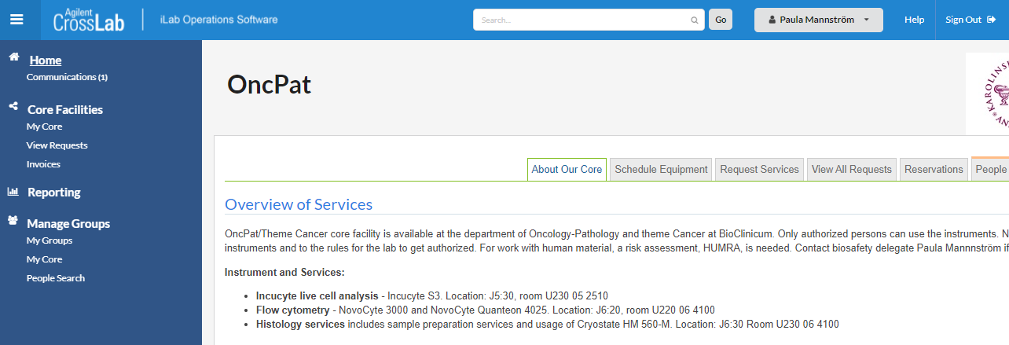

- Open the Manage Memberships section, find the lab member you want to delegate and click on the pencil tool to the right. 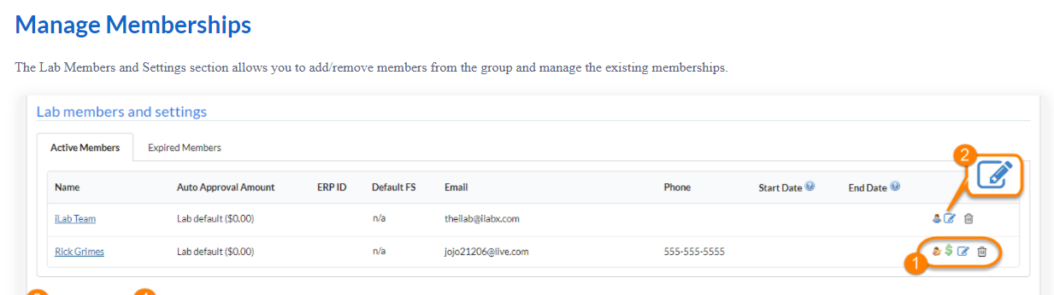

- A new window opens, go to Permissions and choose Manager from the drop down list.
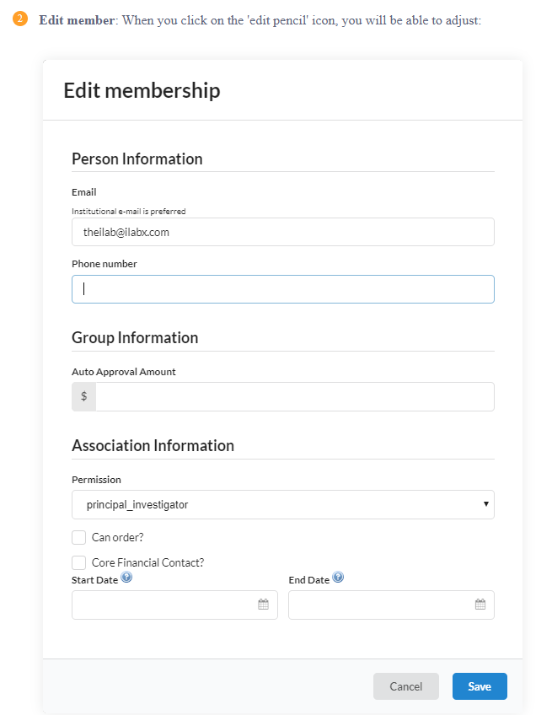

- Press Save. Now the person whose e-mail you have entered becomes a “manager” with administrative rights.

