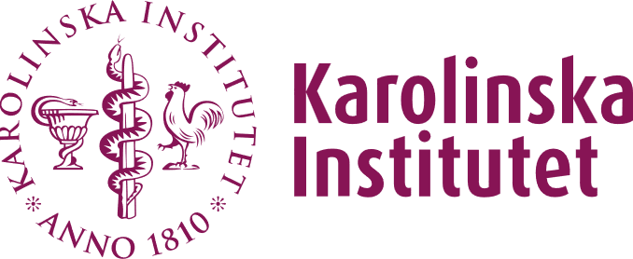
Certificate for learning activities within the doctoral education
This certificate is to be used for educational activities such as journal clubs, seminars and conferences and as an attachment to the form 16. It must be signed by the PhD student and the main supervisor before submission to fu-adm-gph@ki.se
For teaching hours, provide a signed certificate from the course provider. For visits to a research group at another university, provide a signed certificate from the host researcher.
- Journal clubs
Date (YYYY-MM-DD) | Presentation | Presenter & department

- Seminar series or other research seminars*
Date (YYYY-MM-DD) | Presentation | Presenter & Department

*If required time for preparation (ex: reading articles, preparing a presentation or preparing questions….): use the box for journal clubs instead.

- GPH seminars (lunch seminars on Thursdays). Complete 10 of these before reporting for credits. Maximum credits allowed are 0.5 hp for 10 seminars.
Date (YYYY-MM-DD) | Presentation | Presenter & Department

- Workshop and/or symposia
Date (YYYY-MM-DD) and days* | Presentation | Presenter & Department
*One full day of workshop is 8 hours.

- International conference (only international conferences for which your abstract was submitted in concurrence with others). A maximum of 2 conferences is allowed.
Date | Name of the poster or presentation | Conference organizer

Mandatory attachments to the conference:
- Mail confirming the successful submission of the abstract
- Abstract
- Poster or powerpoint presentation

Date, name & signature of the student |  | Date, name & signature of the main supervisor

