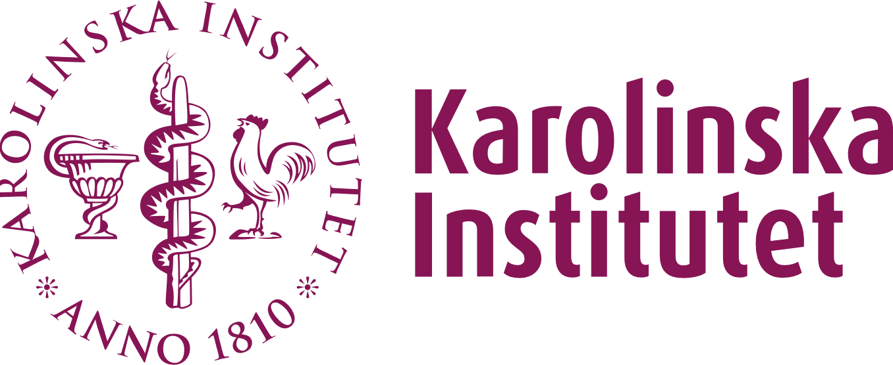
REPORTS ON THE DOCTORAL STUDENT’S LEARNING AND DEVELOPMENT AS A RESEARCHER, INCLUDING ACHIEVEMENT OF OUTCOMES FOR DEGREE

(REDOGÖRELSER FÖR DOKTORANDENS LÄRANDE OCH UTVECKLING SOM FORSKARE, INKLUSIVE UPPFYLLELSE AV EXAMENSMÅLEN)

Purpose of the report
- To give the doctoral student and supervisor the opportunity to summarise and reflect on how the doctoral student has developed knowledge and understanding, proficiency and abilities, as well as judgement and approach as expected at the end of doctoral education.
- To provide the Examination board and the Opponent with information and a tool to help them ask relevant questions about the learning process at the thesis defence

Instructions
Structure the text in the way that suits you best. A tip is to base the text on what is written in the individual study plan (ISP) under the section Degree outcomes, and on the Status report of progress in the half-time report.
If the Examination board and the Opponent understand Swedish, the report can be written in Swedish, otherwise it must be written in English.

The completed report is sent, by the doctoral student, to three different recipients:
- To the Dissertation committee as part of the application for public defence/licentiate seminar (part 3 of the application).
- To the Examination board at the time of the preliminary review, together with the other required documentation.
- To the Opponent, no later than when the printed thesis is sent to him/her.

If the doctoral student wishes, the Doctoral student’s report (or a revised version of it), can be included in the thesis as an appendix.

More information
Mer information på svenska

KAROLINSKA INSTITUTET  REPORT ON THE DOCTORAL STUDENT’S LEARNING AND DEVELOPMENT INCL. ACHIEVEMENT OF OUTCOMES FOR DEGREE | Name of the doctoral student:
- THE DOCTORAL STUDENT’S REPORT
Describe in your own words how you have developed into an independent researcher.
Keep in mind that everything you have done, from conducting research to taking courses and participation in other learning activities, has contributed to your learning and to the achievement of the degree outcomes. Even setbacks and failures may have contributed to important lessons, and don't forget any other research you conducted during your doctoral studies that is not included in the thesis.
Recommended length: approximately 2-3 pages (the box expands when you type or paste text)

KAROLINSKA INSTITUTET  REPORT ON THE DOCTORAL STUDENT’S LEARNING AND DEVELOPMENT, INCL. ACHIEVEMENT OF OUTCOMES FOR DEGREE | Name of the doctoral student:
- PRINCIPAL SUPERVISOR’S REPORT
Describe how the doctoral student has developed into an independent researcher (Note that a licentiate degree does not expect the same degree of independence as a doctoral degree)
Recommended length: approximately 1 page (the box expands when you type or paste text)

KAROLINSKA INSTITUTET
REPORT ON THE DOCTORAL STUDENT’S ACHIEVEMENT OF OUTCOMES FOR DEGREE

- CERTIFICATION OF ACHIEVEMENT OF OUTCOMES FOR DEGREE

If a digital signature is used, the signature refers to the following statements:

The doctoral student
My assessment is that I will have achieved the learning outcomes for doctoral degree/licenciate degree according to the Higher Education Ordinance at the time of the public thesis defence/ licentiate seminar.
Date | Name | Signature

The principal supervisor
My assessment is that the doctoral student will have achieved the learning outcomes for doctoral degree/licenciate degree according to the Higher Education Ordinance at the time of the public thesis defence/ licentiate seminar.
Date | Name | Signature

Outcomes for doctoral education according to the Higher Education Ordinance

